Hessle, South Hunsley and Dale Wards October 2024

- Crime and ASB

Hessle Ward – September 2024

South Hunsley Ward September 2024

Dale Ward September 2024

Detailed crime and ASB data for your area can be obtained by visiting www.police.uk and following the ‘Find your Neighbourhood’ link.

What’s happening in Your Area & Community Priorities?

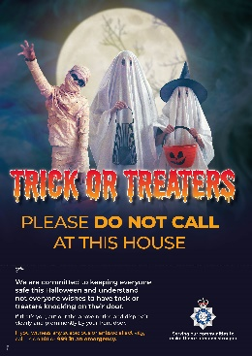

New: HALLOWEEN CELEBRATIONS -visit our website for advice and downloadable posters on how to stay safe this season or sign up to MY COMMUNITY ALERT

Humber-talking has set our priorities, this month we are to:

- Reduce ASB, Criminal damage and Arson this Halloween!
- Prevention of Residential dwelling Burglaries
- Tackle Rural Crime

Here’s a summary of just some of the crimes that have been reported across all three Wards last month:

Residential Burglary reports (several reports across all Wards last month)

1/9/24 Beverley Road, attempt entry to garage with negative results. Following extensive enquiries one adult male has been arrested and charged for the offence.

1/9/24 Richmond Road, entry gained to outbuilding.

5/9/24 Sanderson Drive, 3 unknown males enter victim’s rear garden to gain entry via a kitchen window but are disturbed by victim and subsequently make off.

17/9/24 Mill House, 2 adult males charged and arrested for burglary, enquiries ongoing.

18/9/24 Richmond Road, suspect enters property by unknown means and takes £50 worth in coins before making off.

18/9/24 Vicarage Mews, entry gained to property and items of jewellery removed from within.

26/9/24 Parkfield Avenue, Hanoi burglary after unknown suspect uses an unknown implement to gain entry by snapping/breaking locking mechanism on the side door. Untidy search is conducted before locating car for BMW and leaving the address along with victims’ vehicle, enquiries ongoing.

Business Burglary reports (only one report made last month across Hessle Ward)

2/9/24 Hessle Pharmacy, one adult male arrested and charged for gaining entry to an outbuilding.

Thefts (ten reports made throughout September)

9/9/24 Esso, Boothferry Road, theft of fuel

13/9/24 Boothferry Road, theft from vehicle, wallet, and contents

13/9/24 Humber Yawl Club, theft of boat motor

14/9/24 Tesco Express, one adult male arrested and charged for shop theft.

14/9/24 East Mount, theft in dwelling, personal items stolen.

16/9/24 Tesco Express, one adult male arrested and charged for shop theft.

23/9/24 Shell Garage, theft of fuel

23/9/24 South Cave Service Station, one adult male arrested and charged for shop theft.

28/9/24 Trinity Grove, 3 x bikes and an electric scooter stolen from back garden after lock is found smashed on the ground and suspects bike has been left behind.

28/9/24 Shell Garage, shop theft, suspect named and enquiries ongoing.

Damage (three reports made across all three Wards)

11/9/24 Berryman Way, group of youths have smashed vehicle up. Enquiries underway and suspect named.

23/9/24 Swanland Playing Fields, 5 youths have deliberately caused damage to a signed post with their scooter.

26/9/24 Fishemore Avenue, deliberate damage caused to victims’ vehicle.

Drugs (two new reports made)

8/9/24 A164, adult female arrested following stop search due to manner of driving and is subsequently arrested for possession of drugs. Enquiries ongoing.

24/9/24 Boothferry Road, one adult male and one adult female arrested for drugs related offences.

Other (several other investigations across all three Wards last month) These include public order, stalking, harassment, assault, and malicious communications to name just a few, along with domestic related incidents and blackmail, some of which are still ongoing.

Humber-talking has set our priorities, this month we are to:

- Tackling ASB, reducing damage and Arson

Action - Humberside Police’s Halloween campaign aimed at helping to combat burglary offences, help reduce incidents of Anti-Social Behaviour and to provide advice and support to the local communities.
Officers from neighbourhood policing teams will be going out and speaking to schools across the force about anti-social behaviour and encouraging youngsters to enjoy the festivities without becoming a nuisance in their neighbourhood.



Retailers are reminded of their responsibility not to sell flour and eggs to youngsters on the run up to Halloween and Mischief Night. Posters available from My Community Alert

Our officers are also committed to eradicating the harm that the illegal and anti-social use of off-road bikes cause to the communities through our Operation Yellowfin.

Anyone who wishes to report anti-social or criminal behaviour can contact The Police on 101 or East Riding of Yorkshire Council on 01482 393939

- Preventing Residential dwelling Burglaries

INCLUDEPICTURE "cid:c0382352-7aed-4d0c-9c07-c385c550f043@EURP250.PROD.OUTLOOK.COM" \* MERGEFORMATINET 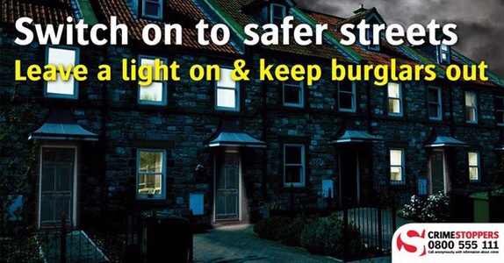

Is anybody home?
Always lock your doors; even when you leave briefly, are outside on your property, or inside your home. Also, keep your valuables in a safe or lockbox when you go out.
- Lights - You can get plug-in timers for your lamps - and timers for your ceiling lights. Don't just light up the hall. Fool a burglar by lighting up the landing, bathroom, bedroom and living room too. Really fox him by varying the times each light comes on.

- Sound advice - Use a plug-in timer for a radio - make it a talk station rather than music.

- Windows - Remember to shut all windows, even small and upstairs ones, when you leave the house, in your garden or in the rear of your property. If you're upstairs, close your downstairs windows and if you're planning some time away, get a trusted neighbour to shut the curtains at night. You could return the favour some time.

  - Tackling Rural Crime

Rural crime is not limited to the farmyard. Serious and organised crime groups are often linked to rural and wildlife crime particularly in relation to theft of agricultural machinery and poaching like hare coursing.
Holderness patrols are reminding farmers to review their security and to keep their properties/equipment safe.
In relation to the security of Tractor GPS Receiver and Screens, please visit the Police website for crime prevention advice around MARK IT, REMOVE IT and LOCK IT.

ACTION: work with partner agencies to protect the community and detect crime, including the Rural Crime Task Force, Farm Watch, NFU and Young Farmer Clubs

How you can help

Your local Neighbourhood Policing Team appreciates the importance of being in the right place, at the right time, for the right reasons to reassure the public, improve public confidence and reduce crime and anti-social behaviour in the area in which we all live and work.
We encourage all residents to call and report any issues where they live so that we can deal with any issues and step up our patrols in that area.

If you feel that there are other issues affecting you or your local community that should be given priority, please inform your local councillors or your Neighbourhood Policing Team.

News and Appeals
Please visit our website www.humberside.police.uk for the latest news & appeals.

FACEBOOK users did you know? You can find out more about the work of your local officers and teams by liking their Facebook accounts: Please visit Humberside Police – East Riding of Yorkshire South www.facebook.com/HumberbeatERYS

My Community Alert – sign up for free.


“My Community Alert” is a free messaging system operated by Humberside Police and Humberside Fire & Rescue Service, giving you information about incidents happening in your area. Choose how you often you want to hear from us and about the issues that matter to you.

Planned Engagement Activities

Humber Talking – Weekends @ Hessle Foreshore

HULL FAIR – Enjoy ALL the fun of the Fair.





